Name: Chandrakant Thakare
PRN : 22310303 Roll No. : 382014
Class : TY CSE AI (B)
Subject : IS (Practical Lab)

Assignment No: 7 Vulnerability Analysis using Nessus

Title : Conduct a vulnerability scan on a virtual machine using Nessus. Identify vulnerabilities and suggest fixes.
Objective : To learn the process of conducting an automated vulnerability assessment using the Nessus tool, analyze the output, and propose remediation strategies for identified security flaws.
Tool Used : Tenable Nessus Essentials
Target System (VM) : IP Address: 10.25.28.229 (Based on scan report msl2_9tiyf3.pdf)

1. Introduction
Vulnerability scanning is a crucial component of information security, involving automated tools to proactively identify security weaknesses in network assets. This practical focused on using Tenable Nessus, a widely recognized vulnerability scanner, to assess the security posture of a target Virtual Machine (VM). The process involved configuring a scan, executing it against the target VM, analyzing the resulting report, and prioritizing the identified risks.
2. Theory and Methodology
Nessus Workflow
- Installation and Setup: Nessus was installed and configured on the attacking machine.
- Scan Configuration: A new basic network scan was created, targeting the VM's IP address (10.25.28.229).
- Execution: The scan was run, which performed various checks, port scans, and service enumerations.
- Reporting: Nessus generated a detailed report summarizing all discovered findings.

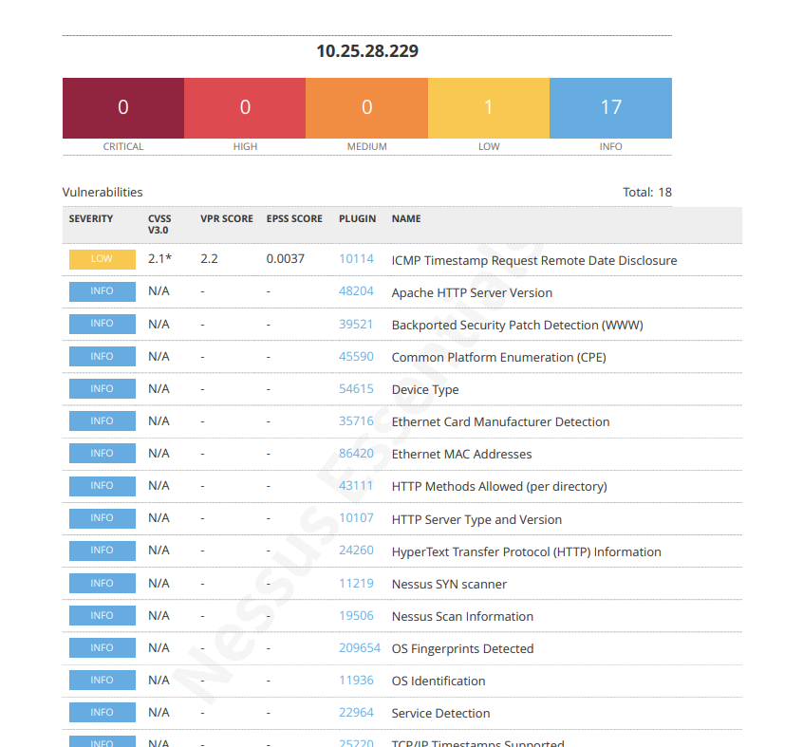
Types of Findings

The results are typically categorized by severity: Critical, High, Medium, Low, and Informational (Info).
Vulnerability: A weakness that an attacker can exploit to gain unauthorized access or cause harm.
Informational (Info): Data points that do not pose an immediate risk but provide valuable intelligence to an attacker (e.g., OS version, running services).
3. Scan Results Analysis
The scan report for the target VM (10.25.28.229) identified a total of 18 findings.
Vulnerability Summary
Severity Level | Count | Status
CRITICAL | 0 | None found
HIGH | 0 | None found
MEDIUM | 0 | None found
LOW | 1 | Vulnerability Identified
INFO | 17 | Informational findings identified
Total Findings | 18 | —

Detailed Findings

A. Key Vulnerability (LOW Severity)
The scan successfully identified one specific security issue:
Plugin ID | Plugin Name | Severity | CVSS v2.0 Score | Suggested Fix Priority
10114 | ICMP Timestamp Request Remote Date Disclosure | LOW | 2.1 | Moderate

Description of Vulnerability: The target system responds to ICMP Timestamp Request packets. An attacker can use this feature to determine the exact date and time of the system, which can aid in other attacks that rely on time synchronization or predict system maintenance windows. This is considered an information leak.
B. Key Informational Findings
The majority of the findings (17) were informational, providing enumeration details:
- Service & Version Enumeration: Apache HTTP Server Version, HTTP Server Type and Version. (This allows an attacker to search for known vulnerabilities specific to that version).
- Protocol Information: HTTP Methods Allowed (per directory), HyperText Transfer Protocol (HTTP) Information.
- Host Data: OS Identification, Ethernet MAC Addresses, Device Type.

4. Suggested Fixes and Remediation
Remediation steps must address both the low-severity vulnerability and the informational leaks to improve the overall security posture of the VM.

A. Fix for LOW Vulnerability (ICMP Timestamp Request)
Vulnerability | Remediation Strategy | Implementation Steps
ICMP Timestamp Request Remote Date Disclosure (Plugin ID 10114) | Disable ICMP Timestamp Responses. | Configure the operating system's firewall (e.g., iptables on Linux or Windows Firewall) to explicitly drop all incoming ICMP messages of type 13 (Timestamp Request). This prevents the system from disclosing its internal clock time to external hosts.

B. Fixes for Informational Leaks (Hardening)
Finding Category | Remediation Strategy | Implementation Steps
Service Version Disclosure | Suppress Banner Information | Modify httpd.conf for Apache: set ServerSignature Off and ServerTokens Prod to prevent version leakage in headers and error pages.
Unnecessary Services / Ports | Disable or Filter Unused Ports/Protocols | Review detected services. Disable unused ones (e.g., mDNS Detection) or apply strict firewall rules to block external access to their ports.
General Patching | Establish a Patch Management Routine | Regularly update OS and applications to patch zero-day or newly disclosed vulnerabilities, reducing future detection in Nessus scans.

5. Conclusion
The Nessus scan showed no critical issues, but one low-severity vulnerability and several informational findings. By disabling ICMP timestamp responses and hiding server version details, the system can be better protected from attackers and reconnaissance attempts. Basic hardening steps will improve overall security.

